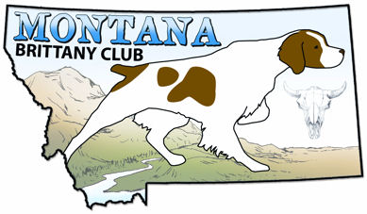
Walking Field Trial Premium List
Montana Brittany Club
AKC Event # 2026682102
Racetrack Grounds, Acton, MT
May 1, 2026
ALL STAKES OPEN TO ALL A.K.C. REGISTERED POINTING BREEDS.
Bitches in season may compete in the last brace of the stake on each course.
This Field Trial is a Flexible Format Trial held under the Rules and Procedures of the
AMERICAN KENNEL CLUB.

Mail entries with check payable to: Montana Brittany Club c/o
Nancy Lane 621 N Meade, Glendive, MT 59330
OR
NEW online entry service available at
https://www.birddogstakes.net
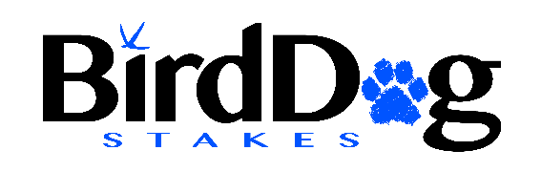
Trial Secretary: Tommie Dahl 406-459-1827.
E-mail: elkhornmountainbritts@gmail.com

ENTRIES WILL CLOSE AT 5:00 P.M. (MDT)
Monday, April 27th, 2026

DRAWING WILL TAKE PLACE AT 6:00 PM (MDT) TUESDAY APRIL 28TH, 2024.
At: 621 N Meade, Glendive, MT 59330
Entries limited to 28 dogs per stake. If entries to one stake are small, entries to another stake may be increased from a waiting list at the discretion of the field trial committee.
Montana Brittany Club reserves the right to change the running order depending on numbers of entries received and the weather.
All stakes will be walking. Judges and bird planters will be on horseback and/or ATV’s.
Participants must be on time at the line with their dogs for their braces – five-minute rule applies.

JUDGES AND STAKES TO BE JUDGED
1. John Cushing, Rexberg, ID – OD, OP, OGD
2. Jim Emmerson, Lake Tapps, WA – OD, OP. OGD

RUNNING ORDER AND ENTRY FEES
Stake/Time/Entry Fee: *
Open Walking Derby 8am $65.00
Open Walking Puppy To follow OD $55.00
Open Walking Gun Dog To follow OP $65.00
*Junior Handlers (under 18 yrs. old) for all stakes: $50.00.
COURSES AND BIRDS
Quail, chukar, pigeons and/or pheasants will be released in all stakes except Open Puppy. All stakes are single course without a bird field. Horseback handling will NOT be permitted in all stakes. A blank cartridge will be fired in all stakes except Open Puppy. All stakes are non-retrieving.
SCRATCH POLICY AFTER CLOSING DATE
Entries will be refunded in full only for dogs that have an injury or illness that prevents running in the registered stake or that are deceased prior to running in the registered stake. Club may require an appropriate veterinary certificate.
PRIZES
Standard AKC Rosettes to all placing dogs.
MTBC OFFICERS
Todd Breitenfeldt, President, Box 883, Whitehall, MT 59759 406-498-5236
Tommie Dahl, Vice President, Box 349, Clancy, MT, 59634 406-459-1827
Tana Kradolfer, Secretary/Treasurer, 5075 Clearview Rd, Belgrade, MT 59714
FIELD TRIAL COMMITTEE
Todd Breitenfeldt - Chairman, Tommie Dahl - Secretary, Leslie Andreas, Terry Courtright, Pam Noe, Ron Noe, Tana Kradolfer
NOTICES:
THIS EVENT IS ON PUBLIC LAND! PLEASE HELP US KEEP THESE
GROUNDS IN GOOD CONDITION BY FILLING YOUR HOLES, PICKING UP TRASH AND SCATTERING MANURE PRIOR TO LEAVING. PLEASE DRIVE ONLY ON THE DESIGNATED ROAD INTO THE TRIAL GROUNDS. STAY OFF THE GROUNDS BEFORE/AFTER THE TRAIL. THESE ROADS CAN BE VERY MUDDY WITH RAIN. BE PREPAIRED FOR ALL WEATHER!
Water: For dogs and horses only. Bring your own drinking water.
Outhouse: Available on site.
Smoking: Only in Vehicles.
Alcohol: May not be consumed until after the competition is complete each day.
Primitive Camping: Permitted on grounds during the trail, no open fires.
Camping with electrical hookups: Available at the Yellowstone Drag Race parking lot near the trial site. Cost $30.00. Restrooms may/may not be available depending on the weather. Fill out the MEAL/CAMPING form below to reserve a spot.
Fire prevention: bucket, shovel, water, and fire extinguisher: recommended for each vehicle.
Hotels: There are many hotels in the Billings, MT area. Reserve your room early!
Racetrack Trial Grounds: Respect this public land! We appreciate your participation in keeping the grounds clean. We ask that all participants park and camp in designated areas. Only the host Club shall be allowed to operate motor vehicles and ATVs within the course limits.
Disaster and Emergency Plan
Police, Fire, Ambulance: Emergency 911
Hospitals: Billings Clinic, 2800 10th Ave N, Billings, MT.
St. Vincent Hospital, 1233 N 30th St., Billings, MT.
Veterinary: Best Friends Animal Hosp., 406-255-0500, 1530 Popelka Dr., Billings, MT
Moore Lane Vet Hosp., 406-252-4159, 30 Moore Ln, Billings, MT
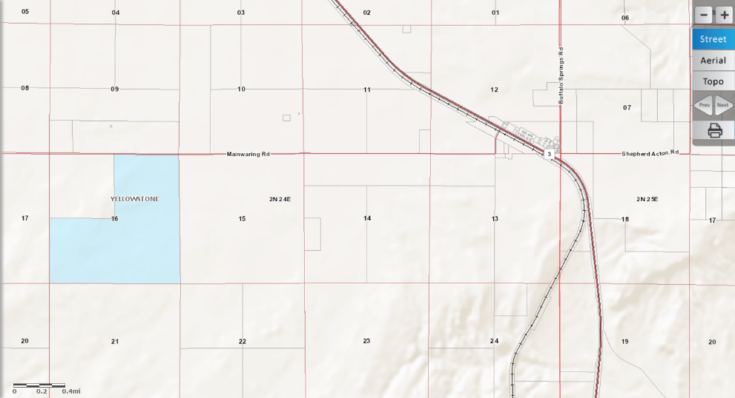
Directions to Racetrack Trial Grounds: From I-90 in Billings take the 27th St. exit. Turn north onto 27th St. and follow it to the top of the hill heading towards the Billings airport. At the top of the hill, you will hit a roundabout. Go left through the roundabout onto Highway 3 towards (Broadview) and Acton. Acton is about 14 miles northwest of Billings. At the small town of Acton, turn left onto Mainwaring Rd. Go about 3 miles west and follow the signs to the trial grounds on the left. If you get to the Yellowstone Drag Strip gate, you have gone about ¼ mile too far. Map: The trial grounds are on the blue (State Land). Section 16, R2N, T24E. Waypoint: 45.92606, -108.74489

Cell Phone Service: Is marginal/poor at the trial site.

This Walking Field Trial occurs the day before a two-day double/double AKC hunt test with the Montana Brittany Club and the North Dakota Pointing Dog Club, on the same grounds. Feel free to enter these events also. Contact Tommie or Todd listed above for information and premiums. Or contact Nancy Lane: 406-989-2480, Email: lzyharts@midrivers.com

OFFICIAL AMERICAN KENNEL CLUB FIELD TRIAL or HUNT TEST ENTRY FORM
Club: Montana Brittany Club |  |  |  | Date(s):  May 2, 2025 |  |  | Event #:  2026682102
Location: Racetrack Trial Grounds, Acton, MT. |  |  |  | Event type (test/trial): Walking  Field Trial |  |  | Enter in Stake/Test:
AKC No. Foreign & List Country |  | AKC DNA |  |  |  | FDSB # |  | I enclose entry fees in the amount of: $
Full Name of Dog:

Breed: | Call Name: |  |  | Sex: |  | Color: |  |  | Date of Birth:
Sire:

Dam:

Name of Breeder:

Actual Owner(s):

Owner’s Address:

City: |  |  |  |  | State: |  |  | Zip:
Name of Owner’s Agent/Handler:

Agent/Handler’s Address:

City: |  |  |  |  | State: |  |  | Zip:
AKC Rules, Regulations, Policies and Guidelines are available on the American Kennel Club website:www.akc.org
AGREEMENT
I certify that I am the actual owner of the dog, or that I am the duly authorized agent of the actual owner whose name I have entered above. In consideration of the acceptance of this entry, I (we) agree to abide by the rules and regulations of the American Kennel Club in effect at the time of this event, and any additional rules and regulations appearing in the premium list of this event and entry form and any decision made in accord with them. I (we) agree that the club holding this event has the right to refuse this entry for cause which the club shall deem sufficient. I (we) certify and represent that the dog entered is not a hazard to persons or other dogs. In consideration of the acceptance of this entry and of the holding of this event and of the opportunity to have the dog judged and to win prizes, ribbons, or trophies, I (we) agree to hold the AKC, the event-giving club, their members, directors, governors, officers, agents, superintendents or event secretary and the owner and/or lessor of the premises and any provider of services that are necessary to hold this event and any employees or volunteers of the aforementioned parties, and any AKC approved judge, judging at this event, harmless from any claim for loss or injury which may be alleged to have been caused directly or indirectly to any person or thing by the act of this dog while in or about the event premises or grounds or near any entrance thereto, and I (we) personally assume all responsibility and liability for any such claim; and I (we) further agree to hold the aforementioned parties harmless from any claim for loss, injury or damage to this dog. Additionally, I (we) hereby assume the sole responsibility for and agree to indemnify, defend and save the aforementioned parties harmless from any and all loss and expense (including legal fees) by reason of the liability imposed by law upon any of the aforementioned parties for damage because of bodily injuries, including death at any time resulting therefrom, sustained by any person or persons, including myself (ourselves), or on account of damage to property, arising out of or in consequence of my (our) participation in this event, however such, injuries, death or property damage may be caused, and whether or not the same may have been caused or may be alleged to have been caused by the negligence of the aforementioned parties or any of their employees, agents, or any other persons. I (WE) AGREE THAT ANY CAUSE OF ACTION, CONTROVERSY OR CLAIM ARISING OUT OF OR RELATED TO THE ENTRY, EXHIBITION OR ATTENDANCE AT THE EVENT BETWEEN THE AKC AND THE EVENT-GIVING CLUB (UNLESS OTHERWISE STATED IN THIS PREMIUM LIST) AND MYSELF (OURSELVES) OR AS TO THE CONSTRUCTION, INTERPRETATION AND EFFECT OF THIS AGREEMENT SHALL BE SETTLED BY ARBITRATION PURSUANT TO THE APPLICABLE RULES OF THE AMERICAN ARBITRATION ASSOCIATION. HOWEVER, PRIOR TO ARBITRATION ALL APPLICABLE AKC BYLAWS, RULES, REGULATIONS AND PROCEDURES MUST FIRST BE FOLLOWED AS SET FORTH IN THE AKC CHARTER AND BYLAWS, RULES, REGULATIONS, PUBLISHED POLICIES AND GUIDELINES.
Signature of owner or
agent duly authorized to make this entry: ______________________________________________
Telephone: |  |  | Email address:

MEAL/CAMPING FORM – MTBC WALKING FIELD TRIAL, 5-1-2026

Send this form in with your field trial entries. If you entered online, you still need to mail this to Nancy. Send to:
Nancy Lane, 621 N Meade, Glendive, MT 59330

Print Name_______________________________

_____ Yes, I/we will be eating lunch on Friday: $7.00/person. How many in your party? _______

Lunches will be sandwiches. Pay at lunch on the trial grounds.

_____ Yes, I/we will be camping at the Yellowstone Drag Strip parking lot. Include a check for $30.00.

This $30 is a flat fee and includes Thursday-Saturday nights and electrical hookup.

Make all check(s) for camping to: MTBC. Pay for lunches at event. Please return this MEAL/CAMPING FORM with your field trial entry forms, Thanks!

All forms go to Nancy Lane in Glendive, MT (see address above). Be aware, mail delivery is slow in Montana.

………………………………………………………………………………………………………………………………………………………

Feel free to participate in the Double/Double AKC Hunt Test at the same location May 2-3.

